RESOLUTION NO.__________

RE: CERTIFICATE OF APPROPRIATENESS UNDER THE
PROVISIONS OF THE ACT OF THE PENNSYLVANIA
LEGISLATURE 1961, JUNE 13, P.L. 282 (53
SECTION 8004) AND BETHLEHEM ORDINANCE NO.
3952 AS AMENDED.

WHEREAS, it is proposed to replace the existing roof shingles at
20 W. Market St.

NOW, THEREFORE, BE IT RESOLVED by the Council of the City of Bethlehem that a Certificate of Appropriateness is hereby granted for the proposal.

Sponsored by: (s)

(s)

ADOPTED BY COUNCIL THIS DAY OF

(s)
President of Council

ATTEST:

(s)
City Clerk

HISTORICAL & ARCHITECTURAL REVIEW BOARD

The applicant is proposing to replace the existing roof shingles at
20 W. Market St.
APPLICATION #1:

Daniel Nigito
20 W. Market St.
Bethlehem, PA 18018

OWNER:

__________________________________________________________________________

The Board upon motion by Connie Glagola and seconded by Marsha Fritz adopted the proposal that City Council issue a Certificate of Appropriateness for the following:

- Use GAF Slateline Antique slate color shingles.

2. Copper flashings and painted drip edge gutters to remain.

3. The motion was unanimously approved.

__________________________________________________________________________

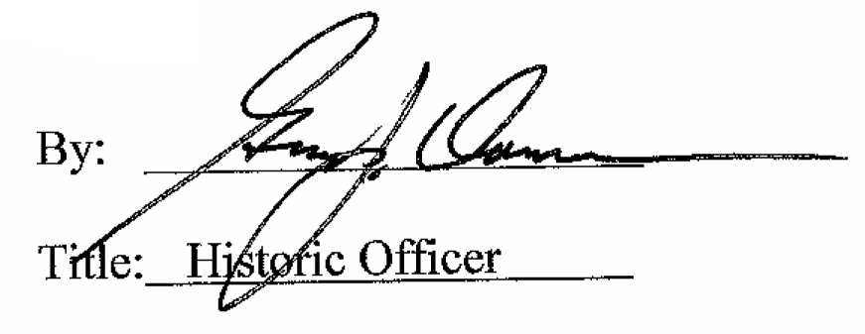

Date of Meeting: June 7, 2017

